## Macintosh HD:Users:wendywalker:WIP:OVY:LOGO:2017_LOGO:Assets:Ovy_BG-01.jpg

# Macintosh HD:Users:wendywalker:WIP:OVY:FREEBIES:product-image-259533157_grande_1b611e7f-38a8-4bec-8d33-002b918187c6_2000x.jpg

# THE LOGO

# BRIEF

## 

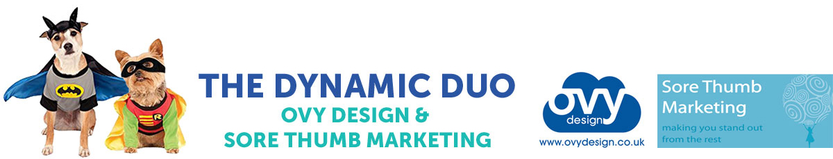

©Ovy Design/Sore Thumb Marketing 2018 | [www.ovydesign.co.uk](http://www.ovydesign.co.uk) | [www.sorethumbmarketing.co.uk](http://www.sorethumbmarketing.co.uk)

## Here are some useful tips to create a great brief to save both time and money and help you get the best from your logo.

# Macintosh HD:Users:wendywalker:WIP:OVY:FREEBIES:product-image-259533157_grande_1b611e7f-38a8-4bec-8d33-002b918187c6_2000x.jpgBEFORE YOU BRIEF…

### Choose a good graphic designer, preferably one who has been recommended to you, who you feel ‘gets’ you and your business. Develop a good working relationship with them and they will help you build your brand and grow your business. Ensure you have the following information available before you supply them with the brief.

# 1. Business name

## After checking online to ensure you find something original, chose a name that suits your business, products or services. Select a name that resonates with your ideal customer.

# 2. Image:

## Think of an eye catching, unique image to represent your business. Avoid using clip art and shared templates. You don’t want to discover another business with the same logo as yourself and get caught with your pants down!

# 3. Font:

## Your designer will select a typeface that is right for your market and not just one that is ‘trending’ or one that you like. Again, think of your ideal customer and the message your logo will send them about your business.

# 4. Strapline:

## This is especially useful if you have selected a quirky name that has no relation to your products or services Eg: Blue Monkey means little to anyone, although it’s a fun, memorable name and has obvious visual advantages but by adding a strapline like ‘Artisan Bakery’ the customer instantly knows what to expect from your business.



©Ovy Design/Sore Thumb Marketing 2018 | [www.ovydesign.co.uk](http://www.ovydesign.co.uk) | [www.sorethumbmarketing.co.uk](http://www.sorethumbmarketing.co.uk)

# THE LOGO BRIEF

# 1.Intro to your brand and business:

## Provide a quick 2-3 sentence summary about what you do.

|  |
| --- |
|  |
|  |
|  |
|  |

# 2. Target audience:

## Here, you might say something like, “Men and women between the ages of 25 and 40 who are health conscious.”

|  |
| --- |
|  |
|  |
|  |
|  |

# 3. Values:

## What feelings and messages do you want the visual design to communicate to your viewer? Eg: Fun, exciting

|  |
| --- |
|  |
|  |
|  |
|  |



©Ovy Design/Sore Thumb Marketing 2018 | [www.ovydesign.co.uk](http://www.ovydesign.co.uk) | [www.sorethumbmarketing.co.uk](http://www.sorethumbmarketing.co.uk)

# 4. Look & Feel

## What aesthetic are you looking for - Contemporary, retro, organic for example? Do you have any particular colours you’d like to use. This is only a guide as your designer will advise which colours work best in your business sector.

|  |
| --- |
|  |
|  |
|  |
|  |
|  |

# 5. Likes & Dislikes

## A great start point is to provide example images of other designs you like or don’t like. Perhaps make a Pinterest board and link it in your brief.

## 

|  |
| --- |
|  |
|  |
|  |
|  |

# 6. Competitors

## Who are your closest competitors? What makes you different, what’s your USP?

|  |
| --- |
|  |
|  |
|  |
|  |

# Macintosh HD:Users:wendywalker:WIP:OVY:FREEBIES:Duo_Word_1200x400px.jpg

©Ovy Design/Sore Thumb Marketing 2018 | [www.ovydesign.co.uk](http://www.ovydesign.co.uk) | [www.sorethumbmarketing.co.uk](http://www.sorethumbmarketing.co.uk)

# 7. Needs

## What do you need at the end of the project eg print ready artwork in pdf format, web compatible .png files etc.

|  |
| --- |
|  |
|  |
|  |
|  |
|  |

# 8. Deadline

## Anything else? If you have any special requests or comments, make sure to add that info to the brief.

|  |
| --- |
|  |
|  |
|  |
|  |
|  |

# Good luck! For more information about logo’s and branding visit our website: <https://www.ovydesign.co.uk/logos-branding>



©Ovy Design/Sore Thumb Marketing 2018 | [www.ovydesign.co.uk](http://www.ovydesign.co.uk) | [www.sorethumbmarketing.co.uk](http://www.sorethumbmarketing.co.uk)